CLOUD COMPUTING LAB

Name: Maria Abdul Malik
Reg No: 2023-BSE-076
Submitted to: Sir Muhammad Shoaib
Class: 5B

LAB #09

Task 1 — GitHub CLI, Codespace setup and authentication
task1_gh_install.png
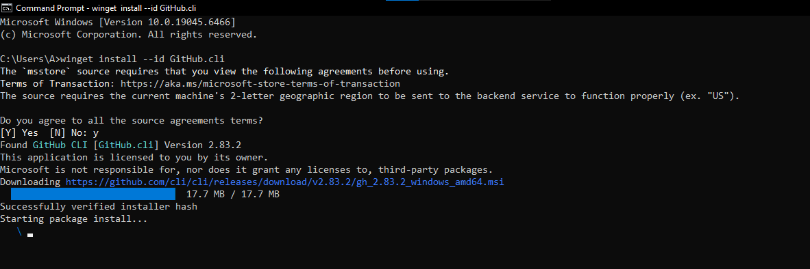
task1_gh_auth_login.png
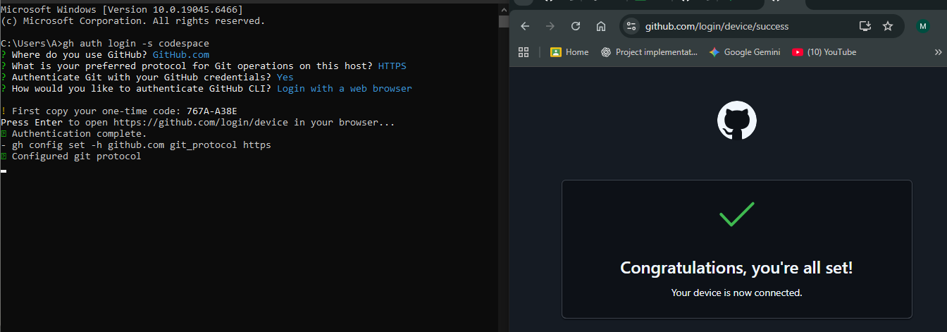
task1_codespace_list.png
task1_codespace_ssh_connected.png
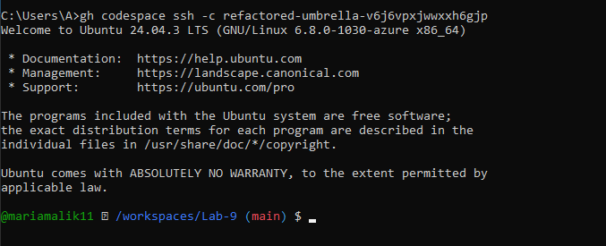

Task 2 — Install AWS CLI inside the Codespace and configure it
task2_aws_install.png
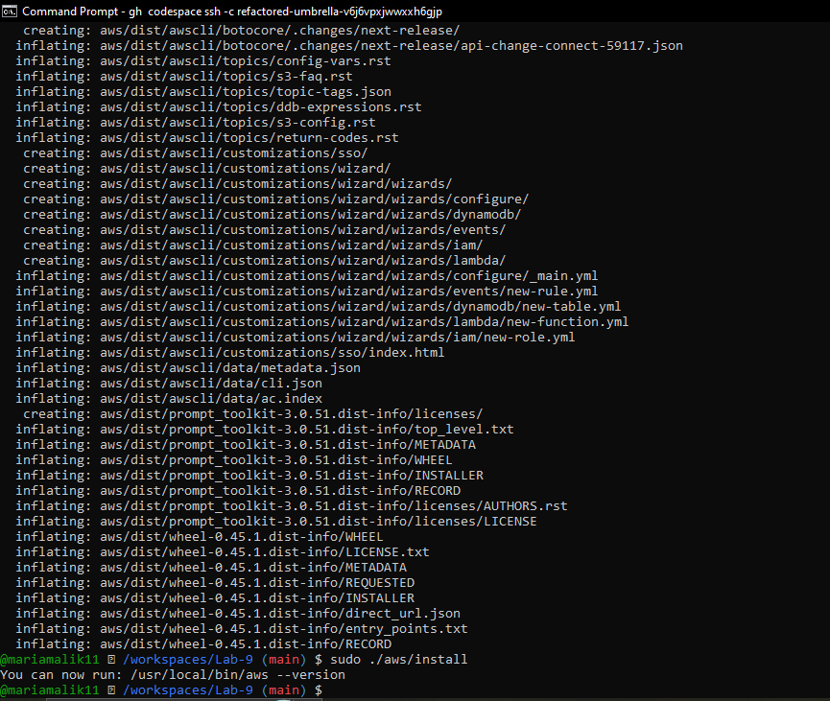
task2_aws _version.png
task2_aws_configure_and_files.png
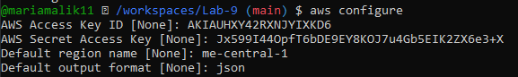
task2_aws_get_caller_identity.png
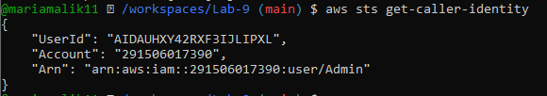

Task 3 — Create security group and add ingress rules using Codespace IP
task3_create_security_group_output.png
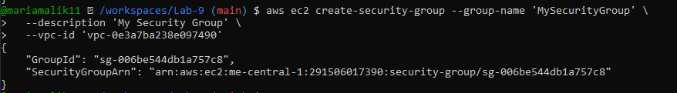
task3_describe_sg_before_ingress.png
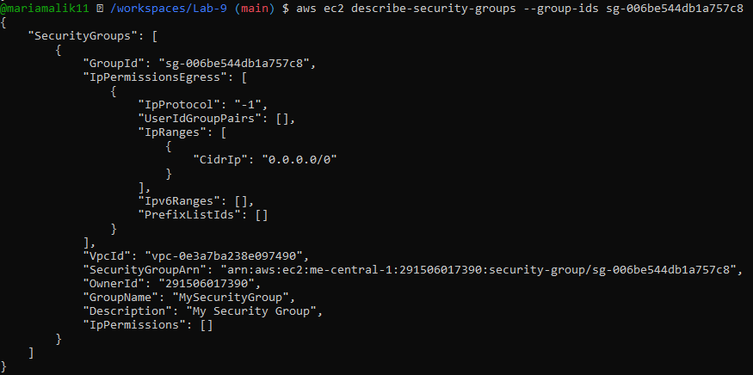
task3_codespace_public_ip.png
task3_authorize_ssh.png
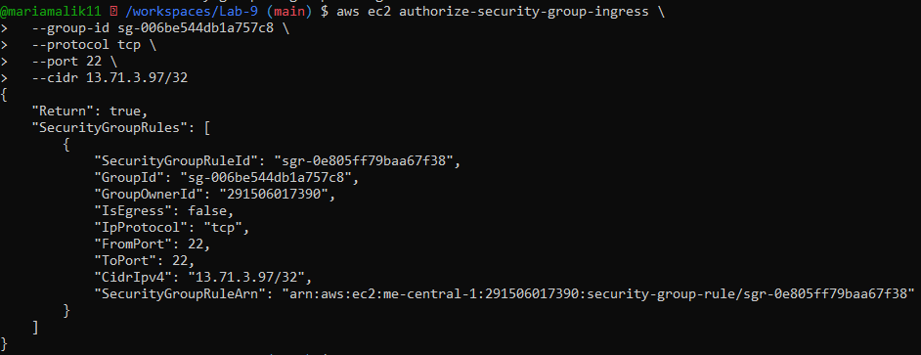
task3 _describe.png
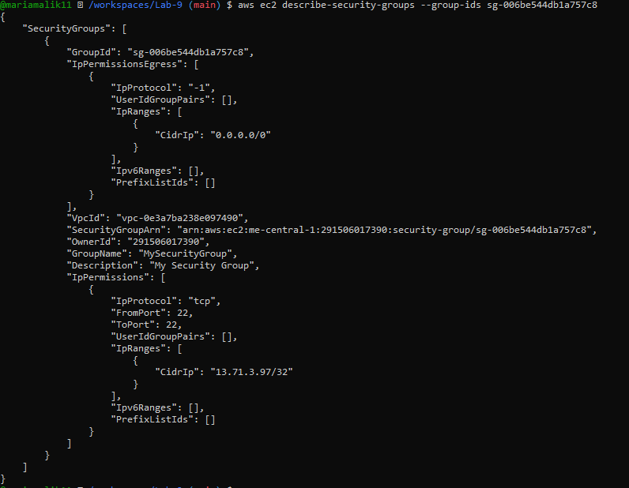
task3_authorize_http_and_describe.png
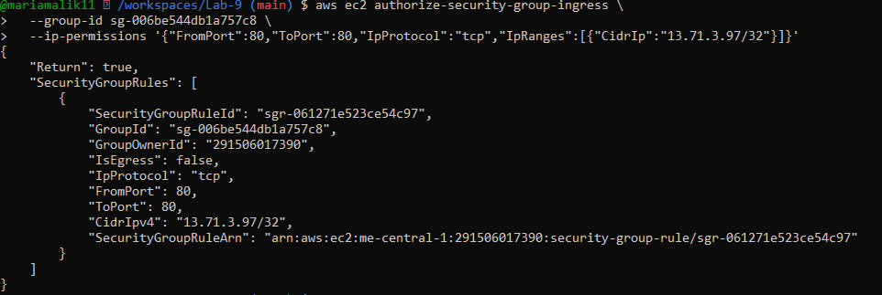
task3_describe_sg_final.png
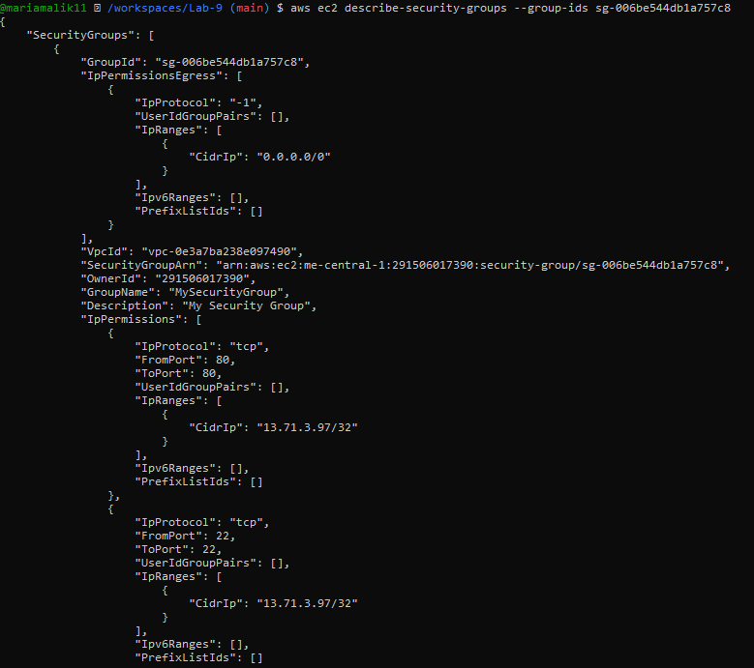

Task 4 — Create a key pair, describe key pairs, and launch EC2 instance
task4_create_keypair_output.png
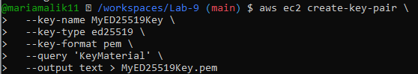
task4_describe_keypairs.png
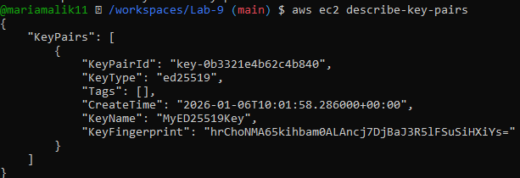
task4_run_instances_output.png
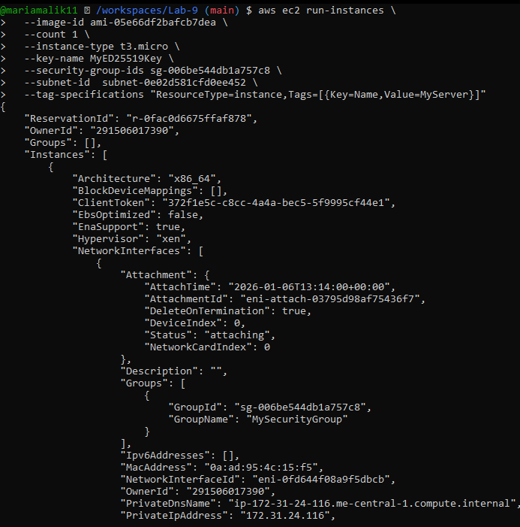
task4_describe_instances_public_ip.pn
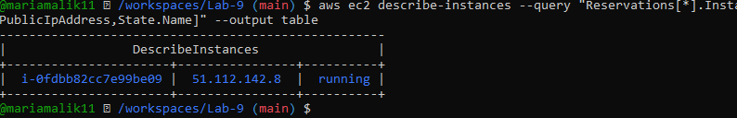

Task 5 — Understand AWS describe-* commands
- task5_describe_security_groups.png
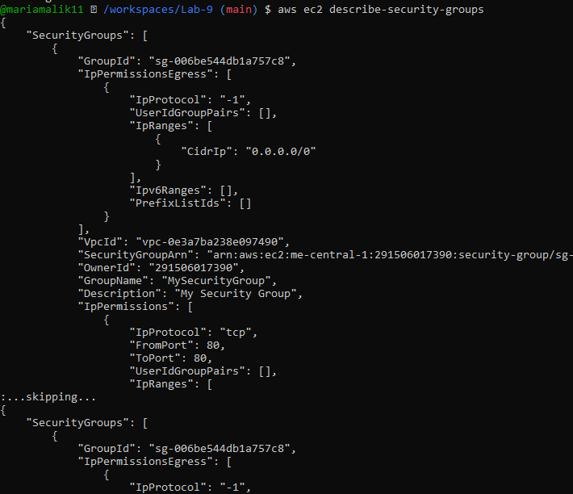
task5_describe_vpcs.png
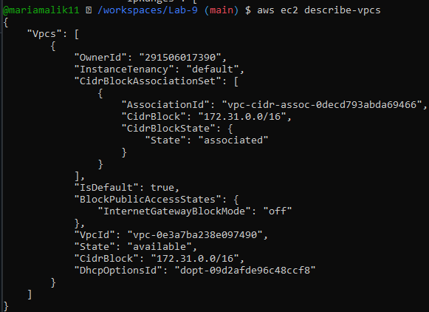
task5_describe_subnets.png
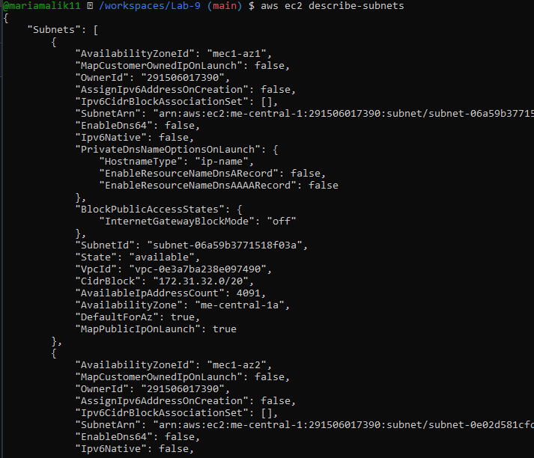
task5_describe_instances.png
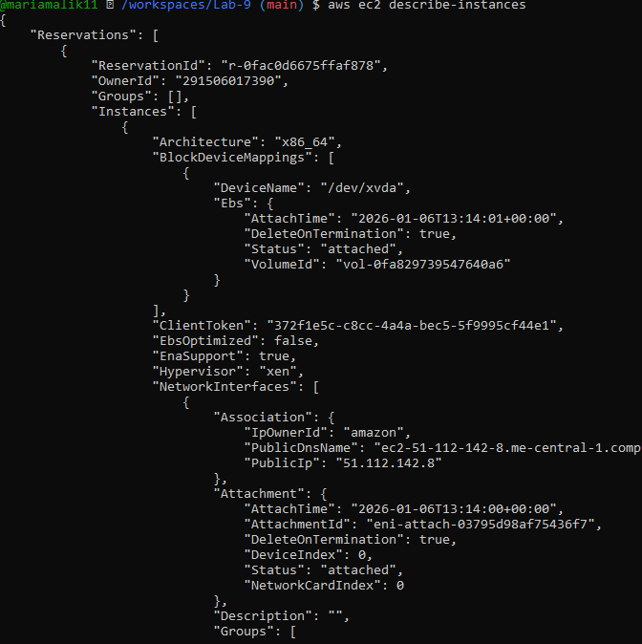
task5_describe_regions.png
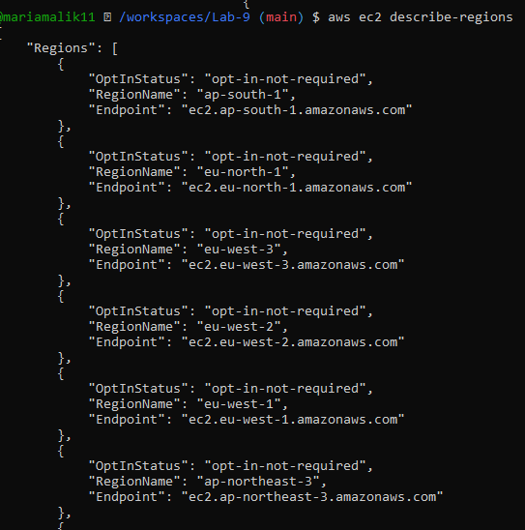
task5_describe_availability_zones.png
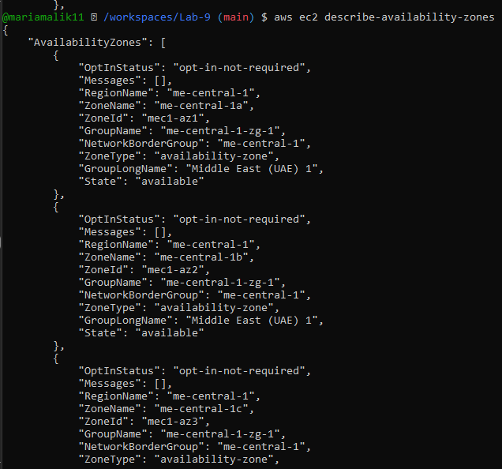

Task 6 — IAM: create group, user, attach policies, create console login & keys
task6_create_group_and_user.png
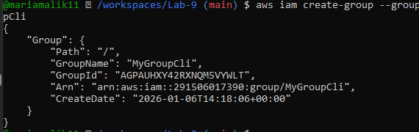
task6_create_group_and_user.png
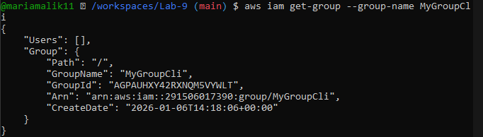
task6_create_group_and_user.png
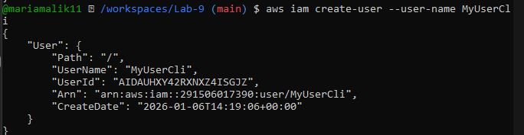
task6_create_group_and_user.png
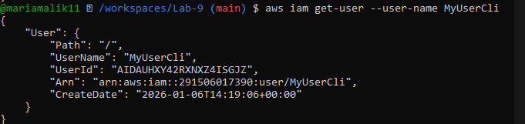
task6_add_user_to_group_and_verify.png
task6_add_user_to_group_and_verify.png
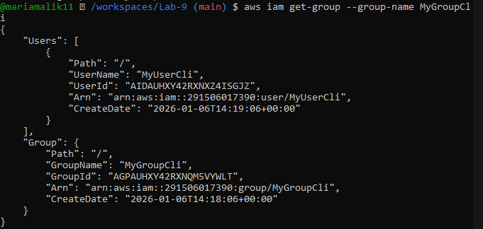
task6_policy_list_and_attach.png
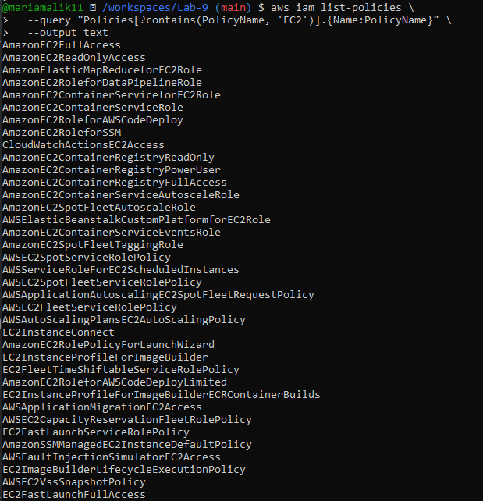
task6_policy_list_and_attach.png
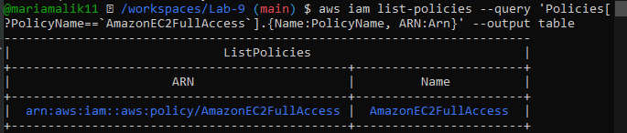
task6_policy_list_and_attach.png
task6_policy_list_and_attach.png
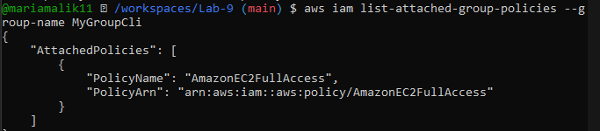
task6_create_login_profile_and_signin.png
task6_create_access_key_output.png
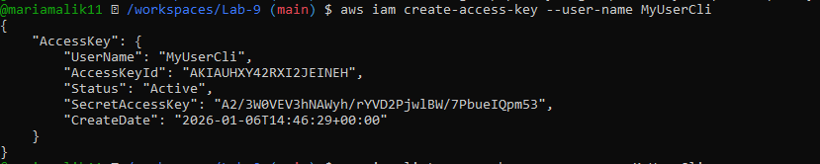
task6_create_access_key_output.pn
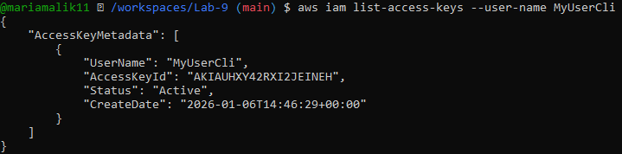
task6_create_access_key_output.png
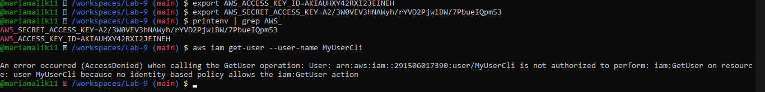
task6_env_exports_and_get_user_error.png

Task 7 — Filters: query with filters to find instances and their attributes
task7_filter_by_tag_public_ip.png
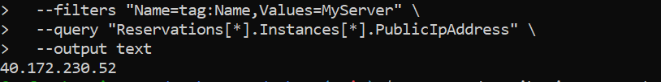
task7_filter_by_instance_type.png
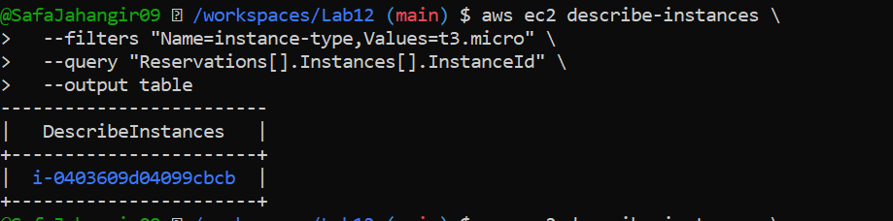
task7_filter_by_subnet.png
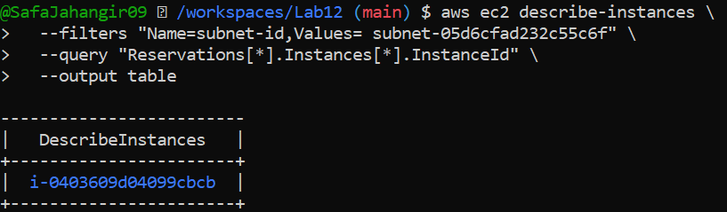
task7_filter_by_vpc.png
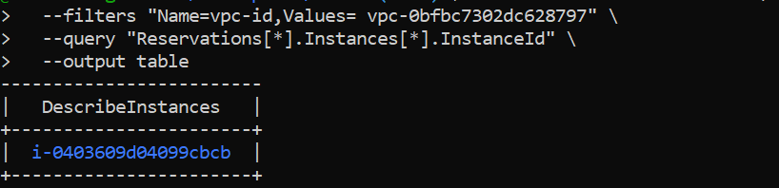

Task 8 — Use --query to format outputs for reporting
task8_query_table_instances_name_ip.png
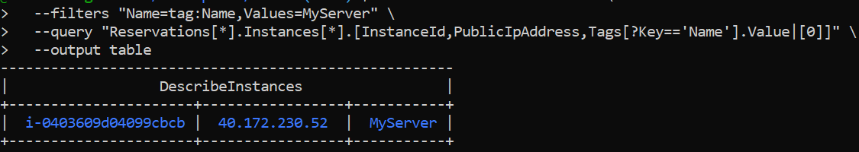
task8_query_table_instance_state.png
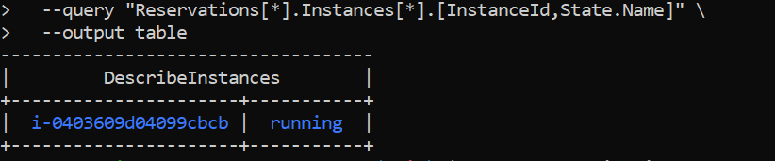
task8_query_table_instance_type_az.png
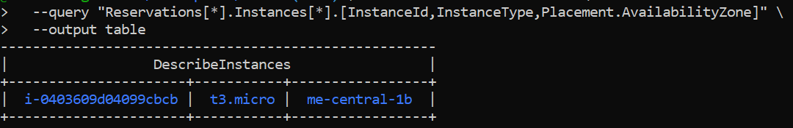

Cleanup — Remove resources to avoid charges
cleanup_terminate_instance.png
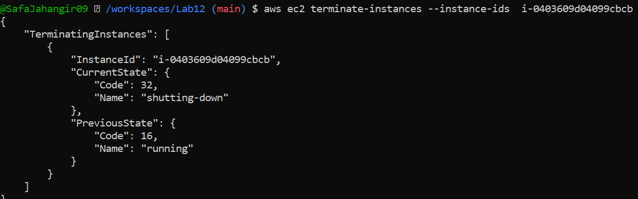
cleanup_delete_volumes_snapshots.png
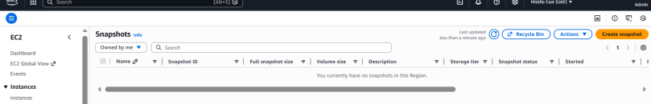
cleanup_delete_security_group_and_keypair.png
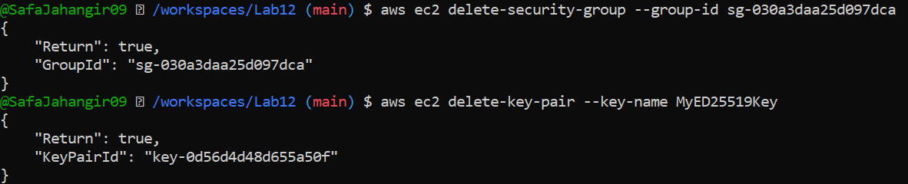
cleanup_iam_users_deleted.png
cleanup_summary.png
